- (9-5ex1) Factor: 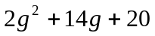
- (9-5ex2) Factor: 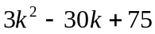
- (10-6ex4) Solve by completing the square: 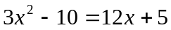
- (9-7ex4) Factor: 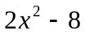

- (9-5ex3) Factor: 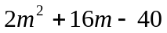
- (9-5ex4) Factor: 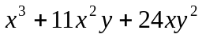
- (10-4ex2) Solve: 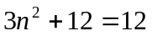
- (10-6ex4) Solve by completing the square: 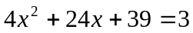
- (9-7ex4) Factor: 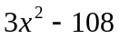

- (9-6ex1) Factor: 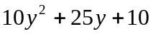
- (9-6ex2) Factor: 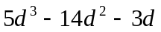
- (10-4ex2) Solve: 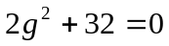
- (10-6ex4) Solve by completing the square: 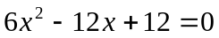
- (9-7ex4) Factor: 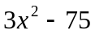

- (9-7ex1) Factor: 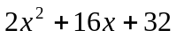
- (9-7ex2) Factor: 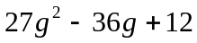
- (10-6ex4) Solve by completing the square: 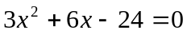
- (9-7ex4) Factor: 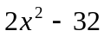

- (9-7ex3) Factor: 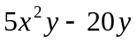
- (9-7ex4) Factor: 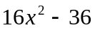
- (10-6ex4) Solve by completing the square: 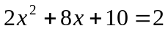
- (10-4ex2) Solve: 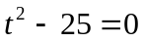
- (9-2ex3) Factor: 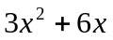

- (9-8ex2) Factor: 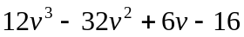
- (9-8ex2) Factor: 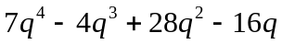
- (10-6ex4) Solve by completing the square: 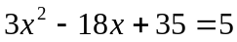
- (9-7ex4) Factor: 